[MongoDB - Google Drive](https://drive.google.com/drive/folders/1BjVlUJlYrtWNdfss_XpvlU9mdGrSTLKo)

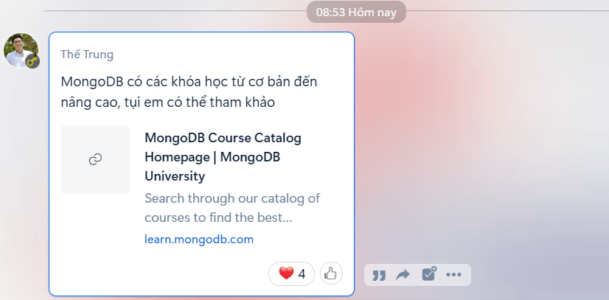

[MongoDB Courses and Trainings | MongoDB University](https://learn.mongodb.com/catalog)

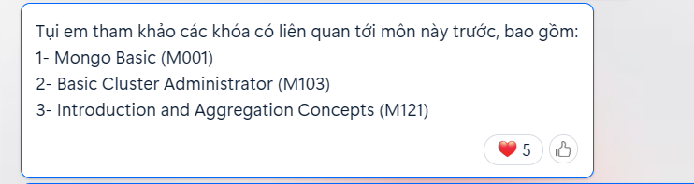

mongosh "mongodb+srv://cluster0.ahrx01g.mongodb.net/myFirstDatabase" --apiVersion 1 --username thaihiep

mongodb+srv://thaihiep:<01677545174anh>@cluster0.ahrx01g.mongodb.net/?retryWrites=true&w=majority

{

"message" : "bad auth : authentication failed",

"ok" : 0,

"code" : 8000,

"codeName" : "AtlasError"

}



C:\Users\FPTSHOP>mongodump -d admin -o "D:\Workspace\mongdb\Json"



C:\Users\FPTSHOP>mongoexport -d admin -c system.version -o "D:\Workspace\mongdb\Bson\sys.json"

-d admin : database

-c : file jon



-o : nơi xuất file đuôi json

Import json : nhập dữ liệu vào file mới



C:\Users\FPTSHOP> mongoimport -d baitap -c Baimau --file "D:\Workspace\mongdb\Bson\sys.json"

